#
# 20190329
#
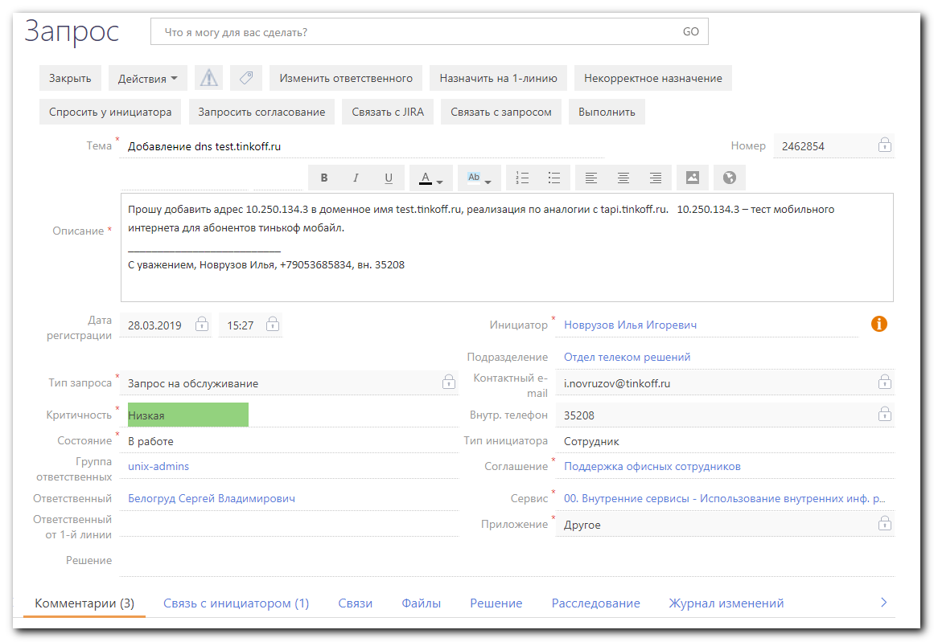
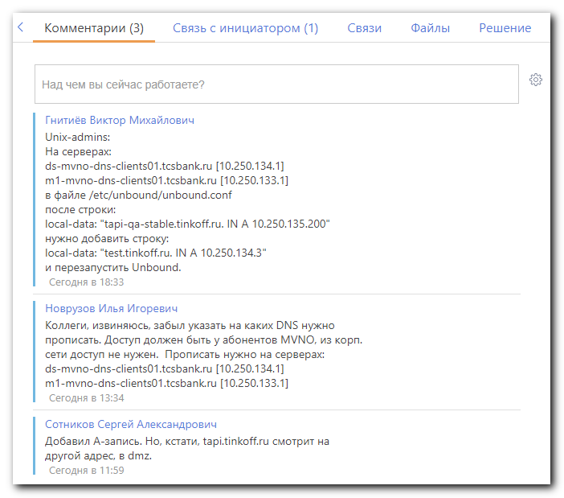
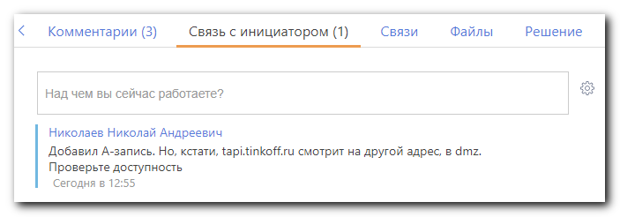

Unix-admins:

На серверах:
ds-mvno-dns-clients01.tcsbank.ru [10.250.134.1]
m1-mvno-dns-clients01.tcsbank.ru [10.250.133.1]
в файле /etc/unbound/unbound.conf
после строки:
local-data: "tapi-qa-stable.tinkoff.ru. IN A 10.250.135.200"
нужно добавить строку:
local-data: "test.tinkoff.ru. IN A 10.250.134.3"
и перезапустить Unbound.

[root@ds-mvno-dns-clients01 ~]# cat $(puppet agent --configprint classfile) | egrep -ie "dns|unbound"
__node_regexp__m1ds-mvno-dns-clients01.tcsbank.ru
role::mvno_dns_unbound
profile::dns::unbound
unbound::params
unbound
unbound::install
unbound::config
unbound::service
profile::unbound_dnstap::dnstap
profile::unbound_dnstap::unbound
profile::dns::zabbix_userparameters
[root@ds-mvno-dns-clients01 ~]#

[s.belogrud@TCS4357]# egrep -irle "unbound" site/
site/profile/files/dns/zabbix_unbound.conf
site/profile/manifests/dns/unbound.pp
site/profile/manifests/dns/zabbix_userparameters.pp
site/profile/manifests/unbound_dnstap/dnstap.pp
site/profile/manifests/unbound_dnstap/unbound.pp
site/role/manifests/dnstap_test.pp
site/role/manifests/mvno_dns_unbound.pp
site/role/manifests/mvno_dns_unbound_to_install.pp

[s.belogrud@TCS4357]# egrep -irle "unbound" hieradata/
hieradata/nodes/akirilochkin-dns-server.adm.m1.tinkoff.cloud.yaml
hieradata/nodes/ds-mvno-dns-clients01.tcsbank.ru.yaml
hieradata/nodes/ds-mvno-dns-infra01.tcsbank.ru.yaml
hieradata/nodes/m1-mvno-dns-clients01.tcsbank.ru.yaml
hieradata/nodes/m1-mvno-dns-infra01.tcsbank.ru.yaml
[s.belogrud@TCS4357]#

#
# Changes in config files for unbound have to be made via puppet.
#

[s.belogrud@TCS4357]# vim hieradata/nodes/ds-mvno-dns-clients01.tcsbank.ru.yaml

[s.belogrud@TCS4357]# git --no-pager log -n 1 -p hieradata/nodes/ds-mvno-dns-clients01.tcsbank.ru.yaml
commit 38684127f4222d74ef4c78b90366d9105cd95cf3
Author: Sergey Belogrud <s.belogrud@tinkoff.ru>
Date: Mon Apr 1 16:50:17 2019 +0300

SD#2462854. Was added one line.

diff --git a/hieradata/nodes/ds-mvno-dns-clients01.tcsbank.ru.yaml b/hieradata/nodes/ds-mvno-dns-clients01.tcsbank.ru.yaml
index deedbce..7dbbd4f 100644
--- a/hieradata/nodes/ds-mvno-dns-clients01.tcsbank.ru.yaml
+++ b/hieradata/nodes/ds-mvno-dns-clients01.tcsbank.ru.yaml
@@ -70,6 +70,7 @@ unbound_local_zones:
- 'tapi-qa.tinkoff.ru. IN A 10.250.135.200'
- 'tapi-qa-master.tinkoff.ru. IN A 10.250.135.200'
- 'tapi-qa-stable.tinkoff.ru. IN A 10.250.135.200'
+ - 'test.tinkoff.ru. IN A 10.250.134.3'
'tcsbank.ru.':
name: 'tcsbank.ru.'
type: 'transparent'
[s.belogrud@TCS4357]#

[s.belogrud@TCS4357]# git commit --author='Sergey Belogrud <s.belogrud@tinkoff.ru>' -m "SD#2462854. Was added one line." hieradata/nodes/ds-mvno-dns-clients01.tcsbank.ru.yaml
[20190401_SD2462854 3868412] SD#2462854. Was added one line.
Author: Sergey Belogrud <s.belogrud@tinkoff.ru>
1 file changed, 1 insertion(+)
[s.belogrud@TCS4357]#

[root@ds-mvno-dns-clients01 ~]# puppet agent -t
Info: Using configured environment 'production'
Info: Retrieving pluginfacts
Info: Retrieving plugin
Info: Loading facts
Info: Caching catalog for ds-mvno-dns-clients01.tcsbank.ru
Info: Applying configuration version 'vm-puppetmaster02p.tcsbank.ru-production-11d92d1887e'
Notice: /Stage[main]/Unbound::Config/Concat[/etc/unbound/unbound.conf]/File[/etc/unbound/unbound.conf]/content:
--- /etc/unbound/unbound.conf 2019-04-01 16:47:29.007018261 +0300
+++ /tmp/puppet-file20190401-17119-zb580a 2019-04-01 16:54:04.643805029 +0300
@@ -55,6 +55,7 @@
local-data: "tapi-qa.tinkoff.ru. IN A 10.250.135.200"
local-data: "tapi-qa-master.tinkoff.ru. IN A 10.250.135.200"
local-data: "tapi-qa-stable.tinkoff.ru. IN A 10.250.135.200"
+ local-data: "test.tinkoff.ru. IN A 10.250.134.3"

remote-control:
control-enable: yes

Info: Computing checksum on file /etc/unbound/unbound.conf
Info: /Stage[main]/Unbound::Config/Concat[/etc/unbound/unbound.conf]/File[/etc/unbound/unbound.conf]: Filebucketed /etc/unbound/unbound.conf to puppet with sum 58f598fd0362047b950781da3328d476
Notice: /Stage[main]/Unbound::Config/Concat[/etc/unbound/unbound.conf]/File[/etc/unbound/unbound.conf]/content: content changed '{md5}58f598fd0362047b950781da3328d476' to '{md5}c3ca14c6130898885fa2642b87c38f67'
Info: Class[Unbound::Config]: Scheduling refresh of Class[Unbound::Service]
Info: Class[Unbound::Service]: Scheduling refresh of Service[unbound]
Notice: /Stage[main]/Unbound::Service/Service[unbound]: Triggered 'refresh' from 1 event
Notice: Applied catalog in 33.70 seconds
[root@ds-mvno-dns-clients01 ~]#

[root@ds-mvno-dns-clients01 ~]# systemctl status unbound
● unbound.service - Unbound recursive Domain Name Server
Loaded: loaded (/usr/lib/systemd/system/unbound.service; enabled; vendor preset: disabled)
Drop-In: /etc/systemd/system/unbound.service.d
└─override.conf
Active: active (running) since Mon 2019-04-01 16:54:04 MSK; 9min ago
Process: 17702 ExecStartPre=/usr/sbin/unbound-checkconf (code=exited, status=0/SUCCESS)
Main PID: 17704 (unbound)
CGroup: /system.slice/unbound.service
└─17704 /usr/sbin/unbound -d

Apr 01 16:54:04 ds-mvno-dns-clients01.tcsbank.ru systemd[1]: Starting Unbound recursive Domain Name Server...
Apr 01 16:54:04 ds-mvno-dns-clients01.tcsbank.ru unbound-checkconf[17702]: unbound-checkconf: no errors in /etc/unbound/unbound.conf
Apr 01 16:54:04 ds-mvno-dns-clients01.tcsbank.ru systemd[1]: Started Unbound recursive Domain Name Server.
[root@ds-mvno-dns-clients01 ~]#

